**Pacific Coast Terminals**

**Notice of Temporary Works**

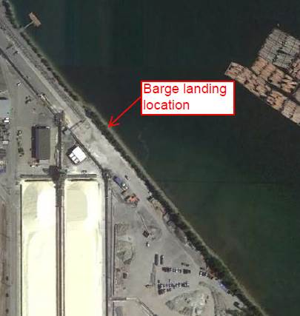As part of the Pacific Coast Terminals Potash project, we would like to inform you of upcoming temporary works that will enable marine delivery of heavy equipment. This “heavy equipment” consists of large segments of two stacker reclaimer units that will help move potash in and out of the storage shed. They are large enough that we cannot safely bring them to site on city roads.

To enable marine delivery, we need to remove up to 10 trees, a 40 metre linear distance, located on the PCT waterfront just north of the yellow sulphur stockpiles. These trees will be replaced and with the same species (Austrian Pine) prior to overall project completion. All work will be done within the City of Port Moody Sound Level By-law work hours.

More information regarding the minor works for clearing this part of the site and marine delivery is listed below for your reference.

|  |  |
| --- | --- |
| **Task Items** | **Details** |
| Site Preparation | Tree removal using front end loader and possibly chain saw; upland soil grading for safe truck access; material removal by truck from site for composting |
| Works Period | November 18 – November 30, 2015 elapsed |
| Work Hours | 7 am – 8 pm, Monday through Saturday |
| Equipment Delivery Period | December 1, 2015 - January 15, 2016 elapsed, approximately of three (3) deliveries in this period; deliveries to be made between 7:00 am – 8:00 pm |
| Equipment Delivery Location | PCT waterfront near historical barge landing area (see map) |
| Permitting | These activities have been permitted through Port Metro Vancouver |

*For further information or inquiries, please contact:*

*Diana Dilworth, PCT Administration and Community Relations Coordinator at (604) 931-9253*