MEMORANDUM
From: | Andrew MacKay, Envirochem | Date: | January 7, 2018
To: | Anika Calder, VFPA  Tiffany Paul, ECCC | Cc: | Andre Olivier, PCT  Colin Reddin, PCT  Mark Adams, Envirowest
RE: | PACIFIC COAST TERMINAL DREDGE WEEKLY MONITORING REPORT #4  DECEMBER 17-23, 2018

This report summarizes capital dredging conducted in Port Moody Arm, BC for the week of December 17-23, 2018. All work continued under relevant permits issued by VFPA, ECCC, DFO and Transport Canada.

OPERATIONS SUMMARY
Cutter suction works for the week work were significantly curtailed due to mechanical issues on the dredger. No losses of a controlled substance (e.g., hydraulic fluid) occurred. Despite curtailed activities, cutter suction dredging advanced from the berth pockets to the eastern end of the navigation channel (see image below which shows complete area in colour).
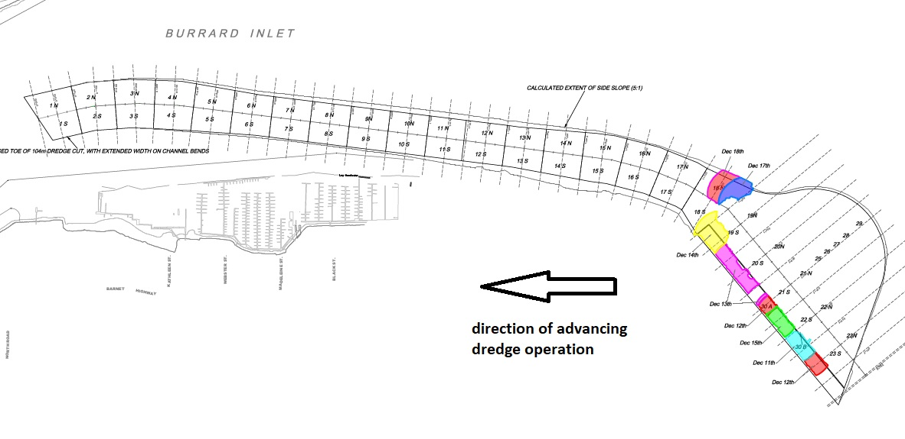

On December 2018, a surface foam was observed in the immediate vicinity of the diffuser discharge area, a similar occurrence during the 1995 dredge program. The foam is associated with dissolved gases released as sediment is raised from the seabed to the higher elevation of floating pipelines then released from the diffuser in the designated discharge area. The foam was sampled and determined to have negligible if any impact on the marine environment. The monitoring team will continue to watch for foam generated by dredge operations and consider controls as and when needed.

TURBIDITY MONITORING
Open Water Monitoring
As per the predictive model, no exceedances of induced turbidity of 8 NTU over 24 hours at 300m from the disposal area were measured during operations. For additional comparitve purposes, suspended solids measured at 300m transect from the containment structure were considerably lower than adjacent Schoolhouse Creek discharge (e.g., 48 mg/L and 408 mg/L respectively).

Shoreline Monitoring Results
Shoreline turbidity was measured as scheduled on December 17, 2018. Results indicate no induced turbidity compared to background readings obtained in July 2018.

FISH, MARINE MAMMAL AND CRAB SALVAGE OBSERVATIONS
No dead or distressed fish or marine mammals were observed in the dredging or disposal areas.
Dungeness crabs (3) were salvaged along the southern margin of the navigation channel, and released into Port Moody Arm at the pier at Barnet Marine Park.

ARCHAEOLOGICAL
No cultural (archaeological) artifacts were observed in the dredge or disposal works areas.

