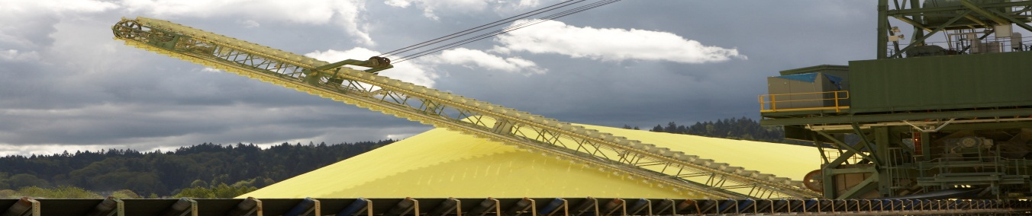
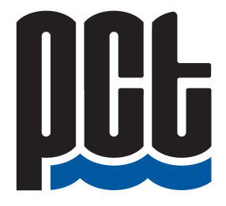

FEEDBACK FORM

We Would Appreciation Your Feedback

Throughout our community engagement process we will compile feedback received and summarize it in an Engagement Summary Report which will be submitted to Port Metro Vancouver for inclusion in their evaluation of the project permit application.

- Were you previously aware of PCT expansion plans? Yes No

- How did you learn about PCT’s expansion plans?

Local Newspaper Channels Newsletter PCT Website
Social Media Family/Friends Other ________________________

- Do you have concerns or comments about PCT’s activities during the construction period? (please provide details)

Noise: _____________________________________________________________
_____________________________________________________________

Vehicle Traffic: _____________________________________________________________
_____________________________________________________________

Land Environment: _____________________________________________________________
_____________________________________________________________

Marine Environment: _____________________________________________________________
_____________________________________________________________

Marine Traffic Safety: _____________________________________________________________
_____________________________________________________________

Pile-Driving: _____________________________________________________________
_____________________________________________________________

Dust/Air Quality: _____________________________________________________________
_____________________________________________________________

- Do you have concerns or comments about PCT’s operations after construction ?
(please provide details)

Noise: _____________________________________________________________
_____________________________________________________________

Vehicle Traffic: _____________________________________________________________
_____________________________________________________________

Rail Traffic: _____________________________________________________________
_____________________________________________________________

Vessel Traffic: _____________________________________________________________
_____________________________________________________________

Land Environment: _____________________________________________________________
_____________________________________________________________

Marine Environment: _____________________________________________________________
_____________________________________________________________

Marine Traffic Safety: _____________________________________________________________
_____________________________________________________________

Dust/Air Quality: _____________________________________________________________
_____________________________________________________________

Emergency Response: _____________________________________________________________
_____________________________________________________________

- Please share any additional comments that you may have in regards to any other aspects of this expansion project:

______________________________________________________________________________
______________________________________________________________________________
______________________________________________________________________________

- Would you like to be added to PCT’s email list for regular updates on PCT operations and expansion plans?

Name: ___________________________________ Email: __________________________________

This form can be emailed to feedback@pct.ca, faxed to 604-936-2951, or mailed to 2300 Columbia St. Port Moody. For further information please contact Diana Dilworth at 604-931-9253. Feedback welcomed until Friday, October 10, 2014

