November 17, 2017
Notice of Marine Construction
Pacific Coast Terminals (PCT) is informing the local community about our two-staged marine construction activities that are being undertaken to enable safer and more efficient bulk carrier (vessel) movement to and from our docks.

For the first phase of activity, PCT has obtained the requisite project permit from the Vancouver Fraser Port Authority, Permit # 15-136, to build a sediment containment berm located just east of PCT Operations. Construction will involve tugs, scows and derricks to deliver and place approximately 33,000m³ of quarry rock on the seabed between approximately December 8, 2017 and no later than February 28, 2018. PCT will be driving 4 piles in order to moor barges overnight during berm construction.

For the second stage of work, dredging of the existing channel from Reed Point Marina to the PCT vessel turning basin will be conducted over the course of an approximate 10-12 week period beginning September 17, 2018. PCT will provide more details in a separate notification regarding dredging prior to work commencing in September 2018.

Marine Berm Construction Working Hours

Marine berm construction will occur from approximately December 18, 2017 to February 28, 2018, excluding weekends and statutory holidays. Daily activities will take place from 7:00 am to 8 pm consistent within the port authority’s standard hours of construction.

Work Site Location
The image on the next page illustrates where dredging equipment will be operating and the location of the new marine sediment containment berm. As noted above, the new berm will be located just east of the vessel turning basin and will intersect the existing berm that was built in 1995.
PCT will continue to keep the community updated through our website and our Channels newsletter. Should you require additional information on the terminal expansion and construction project, or if you would like to register a concern with the project, please visit our website www.pct.ca or call 604.939.7371. After business hours please call 604-931-9211.
For questions regarding the port authority’s permitting process, please contact their Permit Comments line at (604) 665-9570 or permit.comments@portvancouver.com .

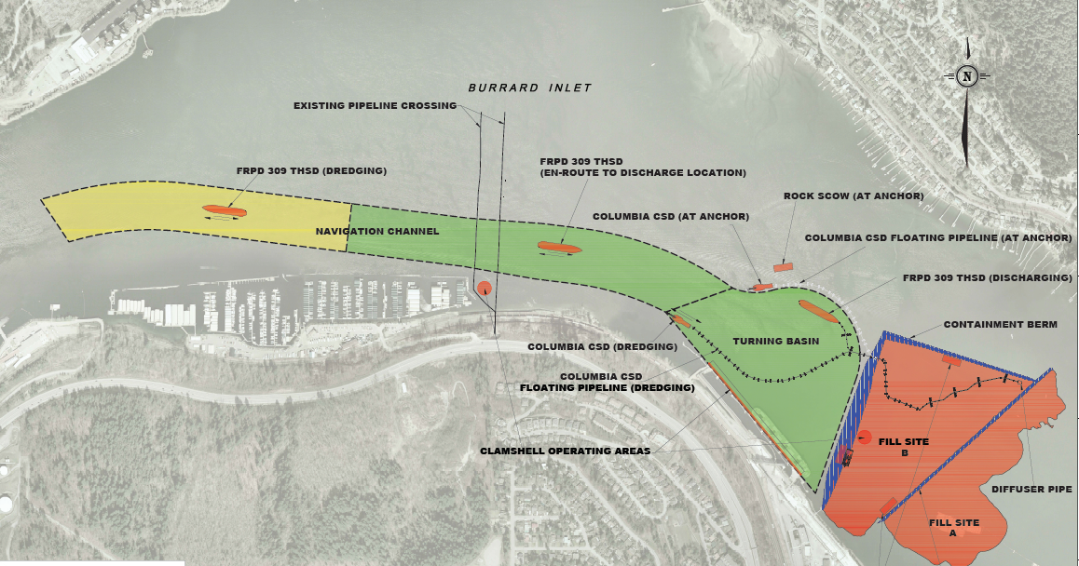
Site Layout Plan
SCOWS AT TIE UP PILES

